

Service Request Form

Instructions
- Step 1: Complete Service Request Form
  - Fill out the form below. This Word document may be used as alternative to the Online Service Request Form, as needed.
- Step 2: Email the Completed Form
  - Share the completed calibration services form with IBA Radcal agents according to your region.
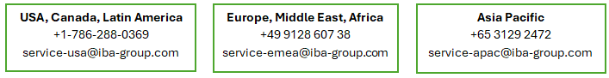

- Step 3: Quote Evaluation and Approval
  - IBA Radcal will assess the requested services and issue a formal quote for your review and approval.
- Step 4: Receive RMA and Shipping Instructions
  - Upon your approval of the quote, IBA Radcal will send a Return Material Authorization (RMA) including detailed shipping guidelines.
  - ⚠️ Important: Equipment sent without an RMA will be rejected upon arrival.
- Step 5: Calibration Service Execution
  - We’re working diligently to meet customer needs. Our current turnaround time is approximately 4-6 weeks from date received at our facility.
  - Once all calibration work is completed, IBA Radcal will issue an invoice outlining the associated costs.
- Step 6: Release for Return Shipment
  - Upon receipt of your Purchase Order (PO) or payment by credit card, IBA Radcal will promptly prepare and ship your calibrated equipment.

Product Information
Products, Serial Numbers | (example)  AGT-P-AG 00-0123  10X6-6M 01-1234
Type of Calibration Request | (select one) Certificate of Conformance, Certified Calibration, ISO 17025 Calibration
Interval | (select one) 6 months, 12 months, 24 months, Warranty Extension
Certified Calibration Points Desired | (optional, if desired different from Standard)  Click here for Standard Beam Codes
Problem(s) Experienced | (if applicable)

Shipping Information
Purchase Order # | (if applicable)
Preferred Shipping Company | (optional)
Preferred Shipping Method | (optional)
Shipping Account Number | (optional)

Ship To Information
Customer Name | (required)
Email | (required)
Phone | (required)
Company / Hospital | (required)
Address | (required)
City, Zip / Postal Code | (required)
State / Territory | (required)
Country | (required)

Bill To Information (if different than Ship to Information)
Customer Name | (optional)
Email | (optional)
Phone | (optional)
Company / Hospital | (optional)
Address | (optional)
City, Zip / Postal Code | (optional)
State / Territory | (optional)
Country | (optional)

