BLUE PHANTOM
MECHANICAL ALIGNMENT CHECK

On all Blue Phantom 3D tanks there are three perpendicular angles (Y/Z, Z/X, Y/X).
One horizontal check (your standard leveling procedure) and two vertical alignment checks (Z inline, Z crossline) will verify if the alignments are correct.
You will need one precise horizontal reference and one precise vertical reference.

With water in the tank, using your alignment cap, perform your normal four corner leveling procedure.
This will position both Y rails, on each side of the tank, parallel to the water. Water is your precise horizontal reference and the procedure places the frame for the mechanics level with the water.

You will need to create and position a simple tool that creates a precise vertical reference.
Using your clear reference tube holder position the end of the tube above the corner of the tank roughly 40mm from each side. This will be on the side that faces your alignment cap. Photo below shows the position above the right corner using the bottom of the tank as a reference. Both corners on the alignment cap side will be used.
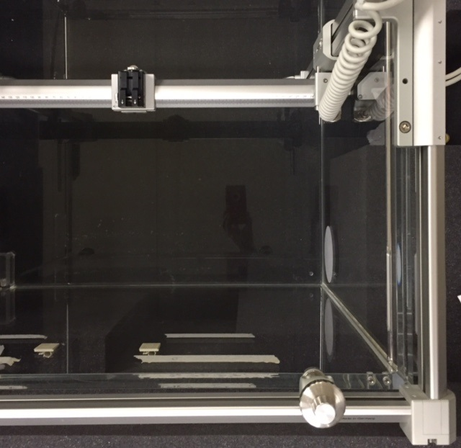

The tool you need to create is a simple weighted plumb line, which is a precise vertical reference.
Items you will need are a medium sized paper binder clip, 70-100 cm of .2-.4 mm dark color line, and a circular weighted object. Type of line is irrelevant but monofilament is best. The paper binder clip will attach to the end of the reference tube holder. You can tie the line to the binder clip, or use the clip to capture the line. The length of the line should be sufficient to keep the weight 10-15mm from the bottom of the tank.
DO NOT ALLOW THE WEIGHT TO TOUCH THE BOTTOM OF THE TANK.
The first check will be the Z-axis vertical alignment in the crossline dimension.

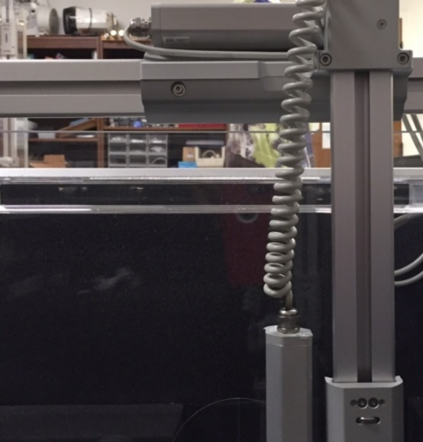 Y TO Z PERPENDICULAR
Raise the Z-axis to the top of the tank. Align the plumb line with the side of the target as shown in the photo below. DO NOT ALLOW THE LINE TO TOUCH THE TARGET. Lower the Z rail carriage to check the vertical alignment of the Z rail in the crossline dimension. The Z rails on each side are independent. You will need to check each side.
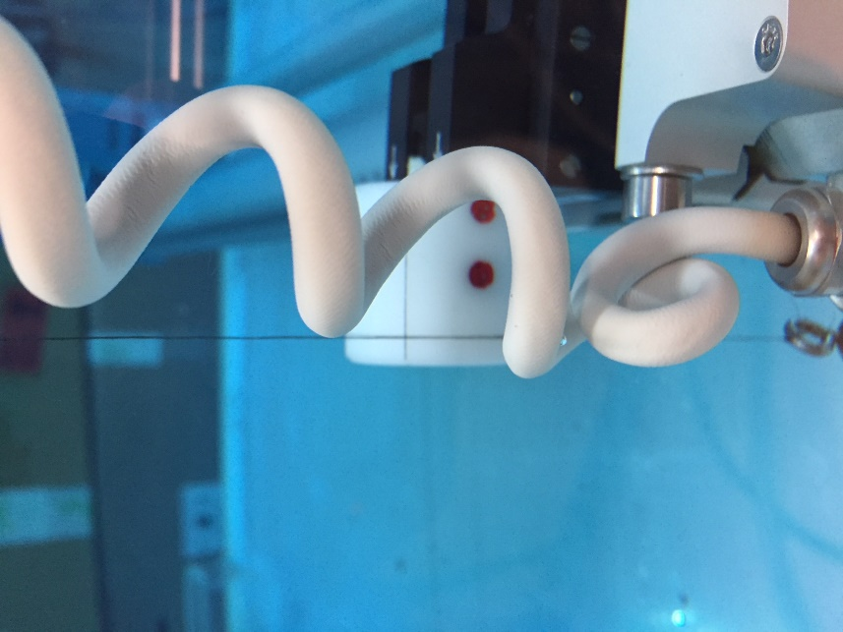
PLUMB LINE ON TARGET
Perform this step on left and right Z-axis. If the line deviates from the target more than 1mm, at full depth on any of these checks, it will need to be calibrated.
The second check will be the Z-axis vertical alignment in the inline dimension.
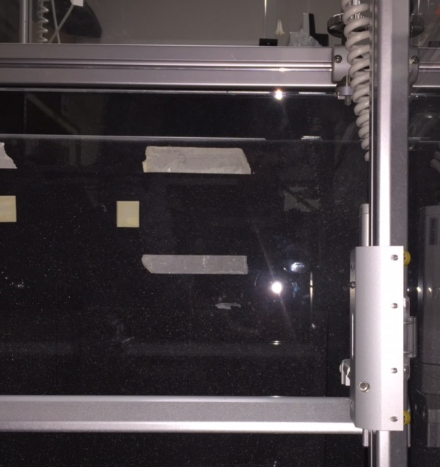 X TO Z PERPENDICULAR
Raise the Z-axis to the top of the tank. Align the plumb line with the front of the target as shown in the photo below. DO NOT ALLOW THE LINE TO TOUCH THE TARGET. Lower the Z rail carriage to check the vertical alignment of the Z rail in the inline dimension.

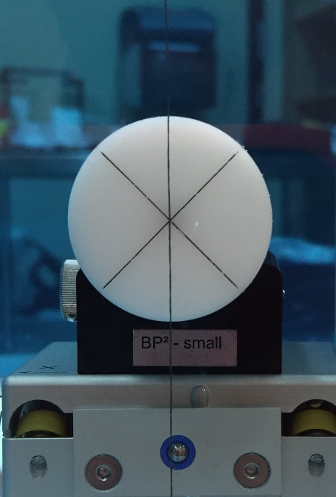

PLUMB LINE ON TARGET

The final check is the Y to X perpendicular position. This angle is from the perspective of the linac and prevents the X carriage from moving the chamber diagonally.
Y TO X PERPENDICULAR (linac view)
This is a visual alignment using the Field Reference Target on the side of the tank and the Crossline on the bottom of the tank. The vertical line in the field reference target and the horizontal line at the bottom of the tank are precise references.
Visually align vertical line of Field Reference Target with horizontal Crossline at the bottom of the tank. Use the Y-axis control to visually position the rear of the X rail frame in line with the two lines.

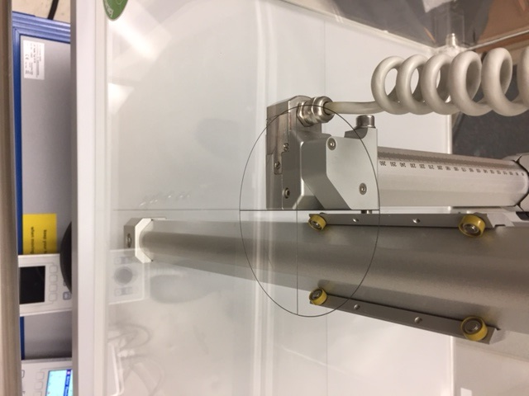 VERTICAL & HORIZONAL LINES ALIGNED WITH X

Without moving any of the axis visually compare the other side of the X frame with the same vertical and horizontal lines.

In the image shown below the alignment on the other side is off approximately 2mm.

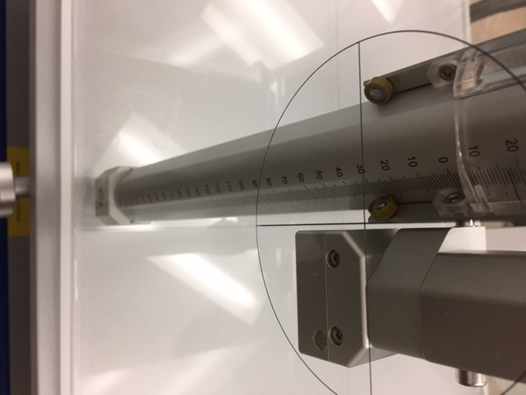 Y CARRIAGE IS 2MM RIGHT OF CENTER

The BP1 has significant play in the frame when the fine adjustment screws are unlocked.
Tighten the fine leveling lock on one corner of whichever side you established as reference. Loosen the locks on the other three corners. This will allow you to move the frame to match both sides.
Do not be concerned if this check is off significantly. This is the least critical of the three angles and the easiest to become misaligned and corrected. For example, the frame could come in contact with a door while being moved. A CAX correction queue should identify an issue here.

